FUN VOCABULARY AND SPEAKING ACTIVITIES FOR the 9th LEVEL
Nume autor: prof. Bratu Ana-Florentina
Unitatea de învăţământ: C.N. NicolaeTitulescu- Pucioasa
Disciplina: Limba engleză
Scopul materialului propus:
-Didactic ( de utilizat la clasă cu elevii)
-De documentare pentru cadre didactice
Nivel de învăţământ: Liceal
Clasa: a-IX-a
1.LET’S KNOW EACH OTHER BETTER!
Each student receives a worksheet and fills in the blank spaces with true, personal information, in their own words. After that, each of them reads out information about themselves.
- I would describe myself as................and.........................
- When I have some free time I like to..................
- I find it very easy to..................and to.................
- My least favourite animals are..................and..................
- The first thing I do when I wake up in the morning is.....................
- Learning English is easy/hard (choose) because...........................
- I want to........................before I am 25.
- I enjoy eating........................and............................. (name 2 dishes)
- It is better to be a man/woman (choose)because................
- I am learning English because.......................
- I hate people who...............................
- Next year I am going to.............................
- I do not like films which...............................
- I like going to parties where.............................
- The best present I have ever received was.........................because..........................
- I have always wanted to.....................
- ............................frightens me most because..........................
- ...............................makes me nervous/cry/laugh (choose).
- If my car was stolen, I ........................
- A friend is someone who.........................
2. What do you remember?
Work with a partner. Ask and answer questions to find out information about the following:
The first time you went hiking | Your first bike | A relative(who is now dead) | A thing that worries you
A party you really enjoyed | Your grandparents | Your first day of school | A hobby you still have
A teacher at school you hated | The town/village where you grew up | An important event from your childhood | Something you want to do when you are 18
What you used to do at weekends when you were a child | One of your best teachers in school | Your birthday party | The street you live on
Your room | A frightening experience | A famous place in the world you would like to visit | One of your classmates in 5th level

3.Who are they?
Work with a partner. Ask and answer questions to fill in the missing information about the following four people.
STUDENT A
Name | Philippa | Kurt | Isabel | Jack
Date of birth |  | 1 June 1979 |  | 22 April 1977
Country of origin |  |  | Portugal | New Zealand
Married or single | single |  | married
Number of children | none |  | 2 boys, 1 girl
Hometown |  | Berlin |  | Wellington
Present job | actress |  |  | police officer
Interests /hobbies | music | gardening
 |  |  | Horse riding | playing rugby
Dislikes | doing the washing-up | cold weather
 |  |  | People who snore | Writing letters
Main ambition | To win an Oscar |  |  | To visit Europe
STUDENT B
Name | Philippa | Andrew | Isabel | Jack
Date of birth | 16th February 1982 |  | 3rd August 1980
Country of origin | Wales | Germany
Married or single |  | married |  | married
Number of children |  | 1 boy |  | Two girls (twins)
Hometown | Swansea |  | Oporto
Present job |  | journalist | teacher
Interests /hobbies |  |  | dancing | Playing golf
 | Learning languages | painting
Dislikes |  |  | ironing | People who smoke
 | Getting up early | Going to the dentist
Main ambition |  | To write a novel | To travel to America
Before you start, work out what questions to ask:
What is Phillipa’s date of birth?
What is Kurt’s present job?
Where does Isabel live?
What two things does Jack dislike?

4.Broken Sentences (Present Simple-Adverbs of Frequency)
Cut and shuffle the broken sentences. Make enough sets for the class working in pairs. Give each group a set of cards and tell them they have to arrange them in 15 sentences.
My wife and I always watch... | ...TV at the weekend.
He never has... | ...toast for breakfast.
We often go out... | ...in the evening.
I speak... | ...French and German.
Mary sometimes plays... | ...tennis on Fridays.
You seldom listen to... | ...music on the phone.
They usually go to the seaside... | ...for their holiday.
Tom and Peter never do... | ...their homework.
Robert usually meets... | ...his friends after work.
I rarely drink... | ...milk or Coke.
He always wears... | ...jeans and a T-shirt.
My father frequently... | ...travels abroad.
Children are always ... | ...polite to the elderly.
People never talk... | ...in the library and the church.
My boss constantly... | ...gives me extra work.

5.Broken Sentences (Tag-Questions)
Cut and shuffle the broken sentences. Make enough sets for the class working in pairs.Give each group a set of cards and tell them they have to arrange them in 15 sentences.
It isn’t cold,... | ...is it?
You stole it,... | ...didn’t you?
It’s Friday today,... | ...isn’t it?
You didn’t say that,... | ...did you?
You’ve got two brothers,... | ...haven’t you?
They are not French,... | ...are they?
They’re working hard,... | ...aren’t they?
He’s spoken to her,... | ...hasn’t he?
He had broken his leg,... | ...hadn’t he?
He loves you,... | ...doesn’t he?
You were lying,... | ...weren’t you?
You will do it,... | ...won’t you?
It’s happened before,... | ...hasn’t it?
You won’t tell anyone,... | ...will you?
He wasn’t at home,... | ...was he?

6. WHAT A QUESTION! (Practising Conditional Type II and bringing arguments pro or against a decision)
- If you knew there would be a nuclear war in one week, what would you do?
- If you were having difficulty on an important test and could safely cheat by looking at someone else’s paper, would you do so?
- If you were to choose, would you like to know the precise date of your death?
- If someone close to you were paralysed and in pain and he asked you to give him poison to die, would you do it?
- If you could prevent either an earthquake that would kill 40,000 people,a plane crash that would kill 200 people, or a car accident that would kill a friend of yours, which would you choose?
- Would you accept 25 years of extraordinary happiness if it meant you would die at the end of the period?
- Would you be willing to reduce your life expectancy by five years if you were to become extremely attractive?
- Would you be willing to become extremely ugly physically if it meant you would live for 500 years at any physical age you chose?
- Would you spend 3 months without washing, brushing your teeth or using deodorants if you were given 20,000 euros and no possibility to explain your reasons to anyone?
- Would you have one of your fingers surgically removed if it somehow guarantee immunity from all major diseases?

7.FIND SOMEONE WHO... (Present Simple)
Classroom activity. Every student has this worksheet and he has to find out information by asking his classmates (using Present Simple) in turn until he finds the person/the people who does/do this activity, then he writes down his/their name(s).
The activity can be done with other tenses, too, for ex Past Simple, Present Perfect Simple,etc.
Find someone who...
1.likes reading books
2.plays computer games
3.knows a joke in English
4.can imitate Donald Duck
5.has a pet
6.watches TV every night
7.lives in a house
8.remembers hid dreams
9.believes in love at first sight
10.plays a musical instrument

8.FIND SOMEONE WHO... (all tenses, modals,etc)
Classroom activity. Every student has a different worksheet and he has to find out information by asking his classmates (l tenses, modals,etc)) in turn until he finds the person/the people who does/do this activity, then he writes down his/their name(s).
Find someone who... Find someone who(se)... Find someone who...
1.can’t whistle. 1.can raise one eyebrow. 1.can make a funny face.
2.feels faint at the sight of blood. 2.will marry until 30. 2.has been to Greece.
3.started school at the age of 6. 3.father has the same name as yours. 3.cannot speak Chinese.
4.has been abroad once. 4.has never flown by plane. 4.was born in a village.
5. will become famous one day. 5.doesn’t like sleeping in the afternoon. 5.won’t become a pilot.

9. THE PREPOSITION GAME
Each student gets a card with missing prepositions in sentences. He fills in the blank space with a preposition and then he exchanges the card with his (left/right/front/back) deskmate and they correct each other’s work. After that, the teacher checks their work.
CARD 1 CARD 2
1.Tell me something.............where you live. 1.Where does Jamie come .........?
2.I’ll see you......8.30. 2.We always walk..........work.
3.Shall we go to the cinema...........Tuesday? 3.Would you like a piece of cake ......your coffee?
4.She was born......October. 4.Did Sally tell you....her new job?
5.There was a storm.......the night. 5.The plates are........the top shelf.
6.Sweden lies........Norway and Finland. 6.He usually gets up at 7.30.......the morning.
7.They went to Hungary......train. 7.Mt flat is......the second floor.
8.He arrived.....Paris last week. 8.She bought the dress ..... only 20$.
10.A Family Tree
Work in groups of six. Each of you has some information about the Johnson family. Working together, fill in the missing names in the family tree and also the jobs of the people in the middle row.(You are only allowed to read out-not show-the pieces of information you have.)
The Johnson Family Tree

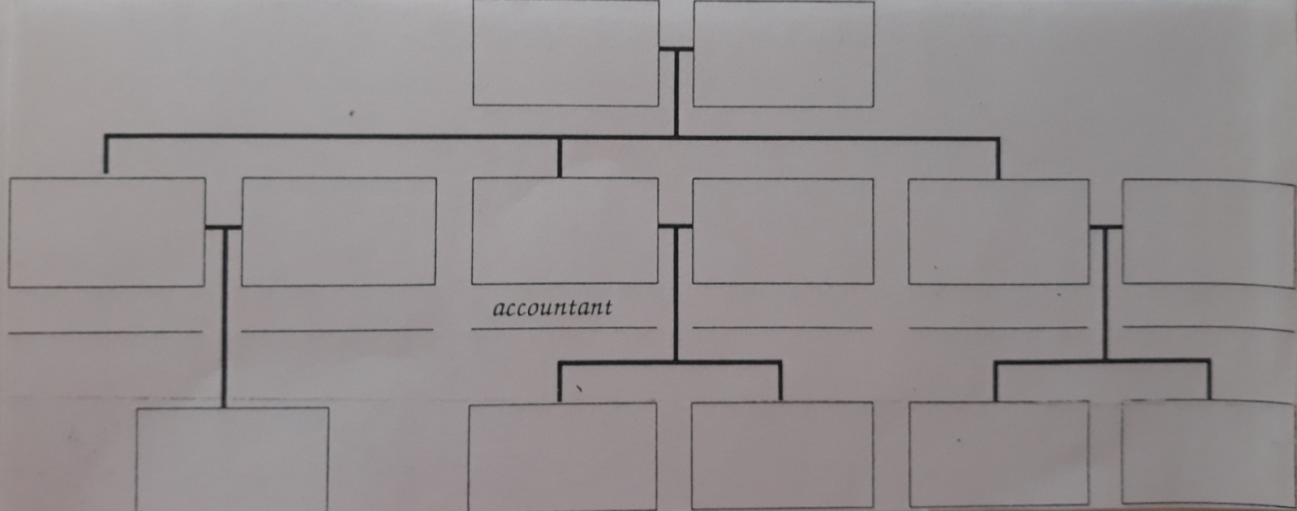
1. 2.
1.Tom’s grandfather is called Douglas. 1.Amanda’smother is a nurse.
2.Sally’s husband is an electrician. 2.Peter has two daughters.
3.Anne has two boys. 3.Sylvia’s daughter-in-law is a doctor.
4.Rebecca is Amanda’s cousin. 4.David and Peter are brothers.

3. 4.
1.The editor is married to David. 1.Sally is Bob’s aunt.
2.Mark is Amanda’s father. 2.One of Peter’s nephew is called Bob.
3.Joanna and Rebecca are sisters. 3.David married Anne.
4.Douglas has two sons and a daughter. 4.Amanda is an only child.
5. 6.
1.Joanna’s father is a teacher. 1.Peter is Sylvia’s son.
2.Sylvia is a grandmother. 2.Sally has two brothers.
3.Nina is Peter’s wife. 3.The accountant is called David.
4.Mark is Sylvia’s son-in-law. 4.Bob and Tom are brothers.

