EVALUATION TEST 1

A Circle the correct word.

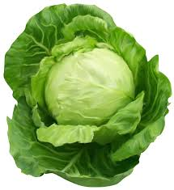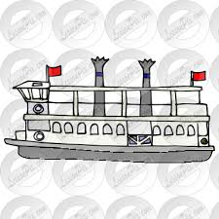
1 cabbage / radish 2 slide / sledge 3 fairy / ferry

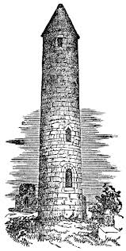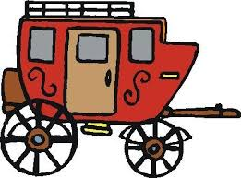
4 sun cream / sun flower 5 bridge / tower 6 car / carriage

B Write words for the numbers.
1 7 .................................... 2 11 ................................... 3 16 .....................................

4 23 .................................... 5 8 ...................................... 6 30 .....................................

C Read and write: am, is, are.
I 1) ............ Manuel. I 2) .................... from Spain. Wendy and I 3) ......................... friends. Wendy 4) ........................ not from Spain. She 5) .......................... from Britain.

D Complete. Then find the countries.
1 __ __ A __ I L
2 I __ __ L Y
3 S W __ __ E N
4 __ O R E __
5 J __ __ A N
6 P O __ __ N __
7 N __ R W __ Y
8 __ __ E __ C E

I | B | R | A | Z | I | L | T
T | J | A | P | A | N | Y | U
A | B | I | U | S | A | E | R
L | A | N | A | W | Y | D | K
Y | R | G | R | E | E | C | E
Z | P | O | L | A | N | D | Y
U | N | K | O | R | E | A | P
S | W | E | D | E | N | F | E

Find two more countries.
.................................................
.................................................

E Write as shown.
1 Erika - France / Mexico
Erika is from France.
She would like to visit Mexico.

2 Raul - Spain / Canada
.........................................................................................................
.........................................................................................................

3 Dimitri - Russia / Holland
.........................................................................................................
.........................................................................................................

4 Melissa - Romania / Cyprus
.........................................................................................................
.........................................................................................................

5 Ali - Turkey / Korea
.........................................................................................................

...............................................................................................................

6 Paula - Poland / Brazil
...............................................................................................................
...............................................................................................................

7 Arya - England / Italy
...............................................................................................................
...............................................................................................................

8 Josh - USA / Japan
...............................................................................................................
...............................................................................................................

F Work on the model.
1 Where is the Colosseum? 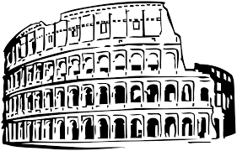
It’s in Italy.

2 Where is ..................................................................... ?
..........................................................................................

3 Where are .................................................................. ? 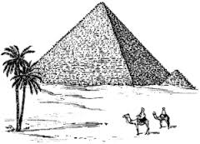
..........................................................................................

4 Where is .................................................................... ?

.........................................................................................................................

5 Where is ............................................................................... ?
.........................................................................................................................

G Choose and complete.
1 I am from Mexico. I my
My name is Rafael.

2 Is ................. from France? he his
.............. shirt is yellow.

3 ............. name is Alice. she her
................ lives in Barcelona.

4 It’s .............. puppy. we our
............... drink cappuccino.

5 ............. hat is funny. you your
Are ................ from Greece?

6 Where is ................... school? they their
Are .................. at home?

H Choose the correct item.
1 Tom and I are friends. .............. are ten.
A They B We C He
2 The boys are happy. .............. are in the park.
A He B We C They
3 You and Mike are students. .............. at school.
A We B They C You
4 ............ are sponges.
A He B They C It
5 Look at Layla. ............. is sleepy.
A She B Her C It
6 Look at the horse. ............ is in the stable.
A It B They C I

I Fill in: there is, there isn’t, there are, there aren’t.
1 ......................................... a puppy in the basket. ♣
2 ......................................... five cups on the table. ☻
3 ......................................... a clown at the circus. ☻
4 ......................................... two boys in the garden. ♣
5 ......................................... seven horses on the farm. ☻
6 ......................................... a bird in the bush. ☻
7 .......................................... a boy in the street. ♣
8 .......................................... three camels in the desert. ☻
9 .......................................... one tiger in the jungle. ☻
10 ........................................ two fish in the bowl . ♣

YES - ☻ NO - ♣

J Read and circle.
Hi!

My name’s Danielle.
I’m 1) French / France and I’m from Paris. I’m 2) twelve / thirteen years old. I’m 3) tall and fat / slim.
I’ve got 4) fair / dark hair and 5) blue / green eyes. My favourite colour is 6) red / blue!
What about you?

Your e-mail friend,
Danielle

Danielle | French | 12 | slim | dark | blue | red

EVALUATION TEST 2

A Circle the correct word.

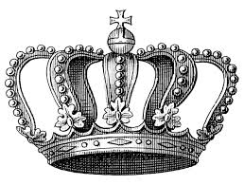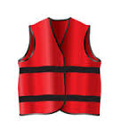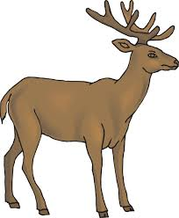
1 hat / crown 2 shirt / vest 3 deer / goat

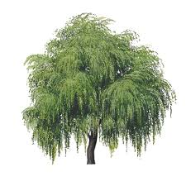
4 olive oil / vinegar 5 sunny / cloudy 6 apple –tree / willow – tree

B Write words for the numbers.
1 10 ................................ 2 3rd .................................. 3 24 ........................
4 19 ................................ 5 22 ................................. 6 4th ........................
7 2nd ................................ 8 30 ................................ 9 1st .........................

C Write in the present continuous.
1 David .....is eating................ (eat) a sandwich.
2 I .............................................. (make) my bed.
3 Jerry ......................................... (talk) on the phone.
4 We ............................................ (watch) TV.
5 Melissa ............................................ (swim) in the pool.
6 Fran and Betty ............................................ (use) my computer.
7 It ............................................ (rain) today.
8 Sharon ........................................... (run) with Tom.

D Fill in the grid.

make dance swim wash bake sit ride look drink type press dig open run hit

washing  ........................  ..........................  ..........................  .......................... | making  ............................  ............................  ............................  ............................ | swimming  .............................  ............................  ..............................  .............................

E Look and write.
1 I am sitting at my desk.
I’m sitting at my desk.

2 I am watching TV.
.................................................................................................
3 You are playing tennis.
.................................................................................................
4 He is eating a big pizza.
.................................................................................................
5 She is crossing the street.
.................................................................................................
6 He is sleeping in his cot.
..................................................................................................
7 You are riding the bike.
..................................................................................................
8 She is saying good bye.
..................................................................................................

F Write sentences.
1 Janet / floor / mopping / is / the
....................................................................................................................
2 Diana / crossing / is / bridge / the
....................................................................................................................
3 baking / Mum / is / pie / a
....................................................................................................................
4 rain / is / the / falling
....................................................................................................................
5 am / opening / the I / book / the
....................................................................................................................
6 Melissa / grass / walking / on / the / is
....................................................................................................................
7 Timmy / his / brushing / hair / is
....................................................................................................................
8 sending / I / email / am / an
....................................................................................................................
9 Dad / hole / digging / a / is
.....................................................................................................................
10 is / Sally / waiting / me / for
.....................................................................................................................

G Match the rhyming pairs.
1 nice a hop
2 flower b. boat
3 vest c. mice
4 mop d. shower
5 night e. right
6 goat f. best

H Read and tick.
1 We go jogging on the afternoon. ..........
We go jogging in the afternoon. ......

2 Sally goes shopping now. ...........
Sally is going shopping now. ...........

3 Where is Alice?
She’s talking with her mum. .............
She talks with her mum. ............

4 Look! The cat jumps over the fence. ............
Look! The cat is jumping over the fence. ...........

5 The kids are playing badminton every day. ...........
The kids play badminton at the weekend. ...........

6 They go to the cinema on Saturdays. ............
They’re going to the cinema on Saturdays. ............

I Read, choose and complete.

My name 1) is Robert. I’m nine years old. I live 2) ............. London, UK. I go to Elton Primary School. Lessons 3) .............. at nine o’clock and finish at half 4) ............ three. My favourite subjects are History and Science. In my free time I like 5) ............ my bike in the park and going to the cinema 6) ............. my friends. I always have lunch with my grandma and grandpa 7) ............ Sundays.

1 A is B are C am
2 A in B on C at
3 A starts B starting C start
4 A quarter B past C to
5 A ride B rides C riding
6 A with B in C to
7 A on B in C at

EVALUATION TEST 3

A Circle the correct word.
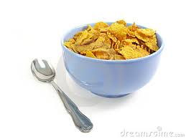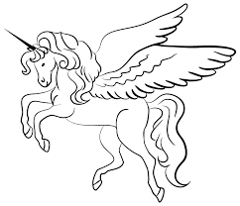
1 camera / TV set 2 rice / cereal 3 horse / unicorn

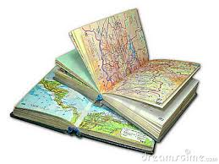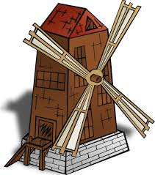
4 notebook / atlas 5 windmill / tower 6 turkey / donkey

B Write words for the numbers.
1 5 ............................ 2 14 ............................... 3 27 ............................

4 31 .......................... 5 13 ............................... 6 24 ............................

C Write the names in the correct list.
Sally ● Britney ● Thomas ● Tony ● Molly ● Steve ● Jessica ● Basil ● Eugene ● Grace ● Vera ● Ralph ● Miles ● Celia

......................................... .........................................
......................................... .........................................
......................................... .........................................
......................................... .........................................
......................................... .........................................
......................................... ..........................................

D Find 15 animals in the grid.
S | H | E | E | P | G | D | O | E
P | E | L | P | R | O | U | H | L
I | L | K | I | Y | A | C | A | E
D | O | G | G | S | T | K | M | P
E | H | I | P | P | O | C | S | H
R | H | I | N | O | C | A | T | A
S | N | A | K | E | E | R | E | N
L | E | O | P | A | R | D | R | T
C | R | O | C | O | D | I | L | E

E Write the plural of the following words.
1 a bus - two buses (2)
2 a puppy - .............................................. (3)
3 a chair - ............................................. (5)
4 a tooth - ............................................ (10)
5 a glass - ............................................. (7)
6 a knife - ............................................ (2)
7 a bush - ............................................... (5)
8 a bench - ............................................... (12)
9 a baby - .............................................. (13)
10 a man - ................................................ (20)

F Rewrite in the plural.
1 It is a potato.
They are potatoes.
2 She is a woman.
........................................................................
3 He is a teacher.
........................................................................
4 It is a fly.
........................................................................
5 It is a church.
...........................................................................
6 He is a man.
..........................................................................
7 She is a nanny.
..........................................................................
8 It is a fox.
..........................................................................
9 It is a cherry.
..........................................................................
10 It is a great day.
...........................................................................

G Put the word in the correct place.
1 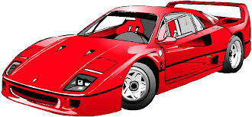 This is a car. (fast)
This is a fast car.

2 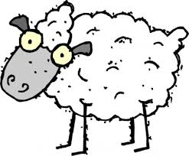 It is a sheep. (white)
....................................................................

3 It is a camera. (expensive)
....................................................................

4 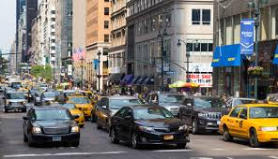 It is a street. (noisy)
.....................................................................

5 It is a beach. (quiet)

...................................................................................

6 He is a clown. (happy)
....................................................................................

7 He is a man. (tall)
.....................................................................................

8 It is a cake. (delicious)
......................................................................................

H Choose the correct answer.
1 How is Helen?
A She’s so nice.
B She is very well
C She is a nurse.

2 Where is your pen?
A I don’t know.
B It’s brown.
C It’s fine.

3 Can you help Susan?
A I can count to fifty.
B Sure. What can I do?
C I know Susan.

4 Does she go to school by bus?
A Let’s sing a song.
B Not every day.
C Her father is a bus driver.

I Read the postcard and put the paragraphs in the correct order.

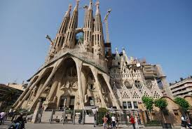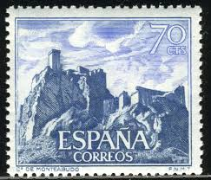

Julie Hastings
Saturday, 15th August 10 Marston Road,
Oxford,
Hi Julie! England
........ There are lots of beautiful old buildings and museums.
This is a picture of La Sagrada Familia. It’s very beautiful.
........ Barcelona is a great place to visit.
....1... It’s fantastic here in Spain. Barcelona is a lovely city and the people are friendly.

See you soon!

Love,
Sandra

Use the information to write a postcard to your pen friend in England.
Write:
● where you are
● what you can see and what there is in the picture
● how you like it

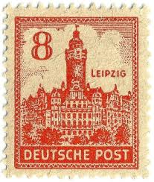

● Berlin, Germany ..........................
● clubs
● lots of shops ..........................
● museums
● nice people ...........................
● Berliner Dome

EVALUATION TEST 4

A Circle the correct word.

1 horse / donkey 2 ice cream / tart 3 swallow / plane

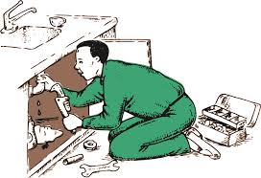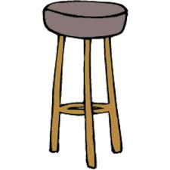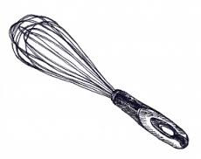
4 postman / plumber 5 stool / armchair 6 whisk / spoon

B Write words for the answers.

1 8 ...................................... 2 7th ..................................... 3 14 ............................................

4 3rd .................................... 5 22 ..................................... 6 26 ............................................

C Complete.

1 J _ N _ _ RY 2 M _ R C _ 3 J _ N _

4 _ _ G _ ST 5 O _ T _ BER 6 D _ C _ M B _ R

D Read and circle the rhyming pairs.
1 hat but mat
2 cake check make
3 pair hair far
4 fit beat meat

E Write the names of the countries and languages.

1 England English
2 Poland .....................................

3 ............................... Greek
4 Japan ........................................
5 Mexico .......................................
6 ................................ Turkish
7 Portugal ........................................
8 ................................. Finnish

F Find 12 names of food and drinks.

B | R | O | C | C | O | L | I
R | I | C | E | A | B | E | C
E | F | T | M | R | L | S | E
A | H | O | I | R | E | A | C
D | A | A | L | O | C | L | R
R | M | S | K | T | I | A | E
U | S | T | I | S | U | D | A
C | H | I | P | S | J | A | M

G Write the plural of the following words.
1 a bus - two buses (2)
2 a phone - ................................................................ (6)
3 a bush - ............................................................... (3)
4 a tooth - ................................................................ (10)
5 a wife - ................................................................ (4)
6 a man - ............................................................... (15)
7 a key - ................................................................ (5)
8 a gym - ............................................................... (11)

H Fill in the correct form of the verbs.
1 Danny ......washes..................... (wash) his car once a week.
2 Fran .......................................... (not / speak) Polish.
3 Mike ...................................... (feed) his dog every day.
4 Pia ........................................ (have) a shower in the morning.
5 His brother ..................................... (swim) very well.
6 We ..................................................... (not / like) shrimps.
7 My mum ........................................... (drive) a red car.
8 They ................................................. (live) in Poland.
9 Andy ................................................ (not / play) football on Mondays.
10 Kate and Lisa ..................................... (wear) a uniform at work.

I Write the questions and answer them about you.
1 you / listen to pop music
Do you listen to pop music?
....Yes,..I do........................................
2 your mum / eat fast food
................................................................................................... ?
No, she ............................

3 your friends / play board games
................................................................................................. ?
Yes, they ............................

4 you / help your mother in the kitchen
................................................................................................. ?
Yes, I ..............................

5 giraffes / have long necks
................................................................................................. ?
Yes, they ..........................

J Write in the present continuous.
1 Anna ............is walking..................... ( walk) to school today.
2 Gregory .............................................. (work) in the barn now.
3 I ................................................ (sit) on this bench.
4 Where ................. Alice ........................... (go)?
5 Chris and Dave .............................................. (play) outside.
6 Vivian ................................................. (not / swim) now.
7 He ............................................... (fly) a kite with his father.
8 They .................................................... (not / watch) TV.
9 Little Tom ............................................... (sleep) in his cot.
10 What ....................... Britney .................................. (cook)?

J Read and match.

1 Where are you from? A Of course they can.
2 Is she feeling happy? B They’re bananas.
3 Can they speak Turkish? C a little town in the south of Spain.
4 Why ar you running? D It’s 80 p.
5 Are they mangoes? E No, she’s upset.
6 How much is a packet of sugar? F because I’m late.

I You want to go to the cinema with a friend. Leave a note for him.

Say:

● what film you want to see.
● where and when to meet you.

Write 35 – 45 words.

EVALUATION TEST 5

A Circle the correct word.
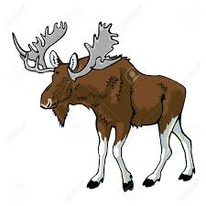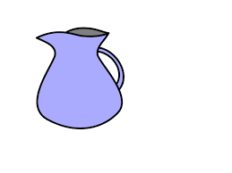
1 camel / moose 2 ship / raft 3 jug / cup

4 watermelon / pear 5 comedy / western 6 boat / submarine

B Write words for the answers.

1 6 .......................... 2 2nd ............................... 3 13 ....................................

4 21 ........................... 5 8th ............................... 6 30 .....................................

C Complete.

1 STR __ B __ RR __ 2 L __ L __ __ POP 3 T __ RT

4 V __ N __ LL __ 5 C __ C __ N __ T 6 H __ N __ Y

D Match the rhyming pairs.

1 berry a) soft
2 goose b) beach
3 loft c) ferry
4 fence d) moose
5 reach e) tense

E Write the names of the countries and languages.
1 England English
2 Turkey ................................
3 France ................................
4 ......................... Italian
5 Japan ...............................
6 ......................... Korean
7 Germany .................................
8 Mexico .................................

F Find 10 more names of drinks in the following grid.

G | I | N | G | E | R | B | E | E | R | Q
H | A | P | P | L | E | J | U | I | C | E
L | E | M | O | N | A | D | E | G | O | P
O | M | I | N | T | S | O | D | A | L | U
N | I | K | I | C | E | D | T | E | A | N
D | L | W | A | T | E | R | L | Y | M | C
O | K | R | C | O | F | F | E | E | A | H
N | C | A | P | P | U | C | C | I | N | O

G Draw the hands on the clocks and watches.

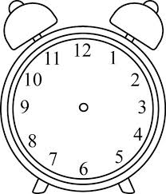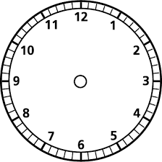

1 It’s three o’clock. 2 It’s half past five. 3 It’s ten to seven.

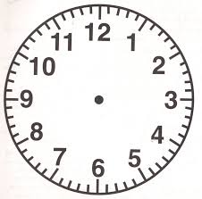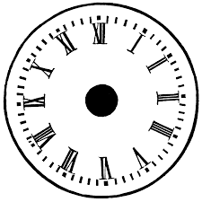

4 It’s five past eleven. 5 It’s six o’clock. 6 It’s quarter to nine.

H Complete the dialogue. Write the words in the correct order.
Monday 7.30p.m. school concert
Tuesday 12.00p.m. football match
Wednesday 4.45 p.m. hockey match
Thursday 9.40 p.m volleyball match
Friday 7.30. p.m class party
Saturday 9.00 a.m. Mark’s violin exam
Sunday 3.15. p.m. tennis game

1 is lesson When hockey your ?
Wednesday five quarter on It’s to at.
Alice When is your hockey lesson?
Jake It’s at quarter to five on Wednesday.

2 concert today Is the school ?
It’s past half seven at.
Jake ..................................................................................
Alice Yes. ........................................................................
3 you your volleyball match Friday got Have on ?
Thursday ten to twenty It’s at on.
Alice ...................................................................................
Jake No. ...........................................................................
4 Mark’s exam When’s violin ?
on o’clock Saturday nine It’s at.
Alice ...................................................................................
Jake ....................................................................................
5 Friday a game on tennis we got Have ?
quarter three It’s Sunday at on past.
Jake .....................................................................................
Alice No. ............................................................................
6 is party When the class?
seven on at Friday half It’s past.
Jake ......................................................................................
Alice .......................................................................................

I Write in the present simple or continuous.
1 Stuart .................................... (go) camping every summer.
2 Danny .................................... (feed) his cat twice a day.
3 Alice ..................................... (watch) TV at the moment.
4 ......................................................... (she/have) a shower now?
5 I ........................................ (hate) cold weather.
6 Dave and Kate ....................................... (be) cousins.
7 They ..................................... (have) a game of chess now.
8 He ........................................ (always/eat) an apple in the morning.
9 I can’t go out. I .................................... (do) my homework.
10 ................................................... (Jim/go) home now?

J Add at, on, in.
............ 7 o’clock ............... July ............ the winter
............ Sundays ............... the morning ........... 1994
............ night ............... 9 o’clock ........... Christmas
............ 10th May .............. the spring ........... Friday
............ 1st March .............. the weekend ........... Christmas Day
............ 10 o’clock .............. work ............ the first floor

K Write the opposites in the crossword.
1
2
3
4
5

Down Across
1 good 2 big
2 long 4 black
3 thick 5 old

Bibliography:
New Round –Up , Virginia Evans, Jenny Dooley, Pearson Longman 2010
Key English Tests, Cambridge University Press 2010

